MODEL QUESTION PAPER

B.E. INSTRUMENTATION AND CONTROL ENGINEERING
SEMESTER V

IL331 – NETWORK ANALYSIS AND SYNTHEIS

Time : 3 Hours Max Marks : 100

Answer All Question

PART – A (10 x 2 = 20 marks)

1. Define poles and zeros of a Network Function and plot them in a complete plane for
$N(s)=\frac{4(s+1)}{(s^{2}+4s+\text{20})}$.

2. A two port network is characterized by V₁ = 10I₁+5I₂ and V₂ = 5I₁+12I₂. Find the transmission parameters A and C.

3. State any three properties of RC driving point impedance function.

4. Check whether the function $F(s)=\frac{3s^{2}+5}{s(s^{2}+1)}$ is positive real or not.

5. Find whether the impedance function $Z(s)=\frac{K(s^{2}+1)(s^{2}+9)}{(s^{2}+2)(s^{2}+\text{10})}$ is an LC.

6. Draw any one shape of configuration of synthesis for the immittance function $F(s)=\frac{2(s+1)(s+3)}{(s+2)(s+6)}$

7. Define zeros of transmission and their properties.

8. What are the two basic types of constant – resistance networks and their important properties?

9. What is the use of frequency transformation in filter design?

10. Compare Butterworth filter with chebyshev filter.

PART – B (5 x 16 = 80 Marks)

11. An impedance function has simple poles at-1 and –4 and simple zeros at –2 and –5 z(0)=10.
Synthesize the impedance function in a foster form and a causer form. (8+8)

12.a) For the network shown in Figure 12(a), show that $y_{\text{11}}=\frac{(s+1)(s+3)}{(s+2)(s+4)}$ and $−y_{\text{12}}=\frac{k(s+1)}{(s+2)(s+4)}$. Determine the value for K.

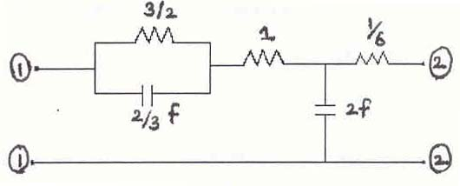
Figure 12(a)

OR

12.b) For the network shown in Figure 12(b), find the transmission parameters and the h-parameters.

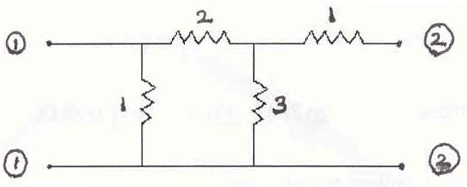

Fig.12.(b)

13.a)i) Explain the terms “Casuality” and “Stability” in network synthesis in time domain and frequency domain. (4+4)

ii) Test the following polynomial for the Hwuritz property.
s⁷+2s⁶+2s⁵+s⁴+4s³+8s²+8s+4 (8)

OR

13.b) Determine whether the following functions are positive real.
(i) $F(s)=\frac{s+2}{s^{2}+3s+2}$ (3)

(ii) $F(s)=\frac{3s^{2}+5}{s(s^{2}+1)}$ (5)

(iii) $F(s)=\frac{(s^{2}+2s+\text{25})}{(s^{2}+5s+\text{16})}$ (8)
14.a)i) Describe the synthesis of lattice networks terminated in a load of constant resistance R. (8)

ii) Synthesis the lattice network terminated in a 1-ohm resistor to meet the specification
$Z_{\text{12}}=\frac{s^{2}−s+1}{s^{2}+s+1}$.
OR

14.b) For the networks shown in Figure.14(b), show that

(i) $\frac{V_{2}}{V_{0}}=\frac{1}{(2+y)}$ (6)

(ii) Synthesize Y when $\frac{V_{2}}{V_{0}}=\frac{0\text{.}5(s^{2}+2)}{(s^{2}+2s+2)}$ (10)

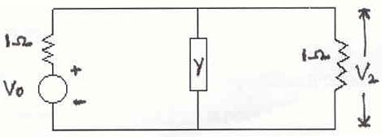

Fig.14.(b)

15.a)i) Synthesize a third order Butterworth low pass filter terminated in 1-ohm resistance and having transfer impendence Z₂₁ of third Butterworth polynomial. (10)

ii) Hence synthesize the changes in the above filter when it is terminated in a load of 600 ohm instead of 1-ohm. (6)

OR

15.b) Describe in detail the design of high pass filter and band pass filter from the design of low pass filter using frequency transformation. (8+8)

-----

